Name-Ujjawal Mandhani
Batch-F6
Enroll No.-9918103237
COA Lab-7

Question 1:

(a)
# BEGIN 000H
LXI H,C050
MOV A,M
INX H
ADD M
STA C052
HLT
# ORG 050
# DB 55H , 66H
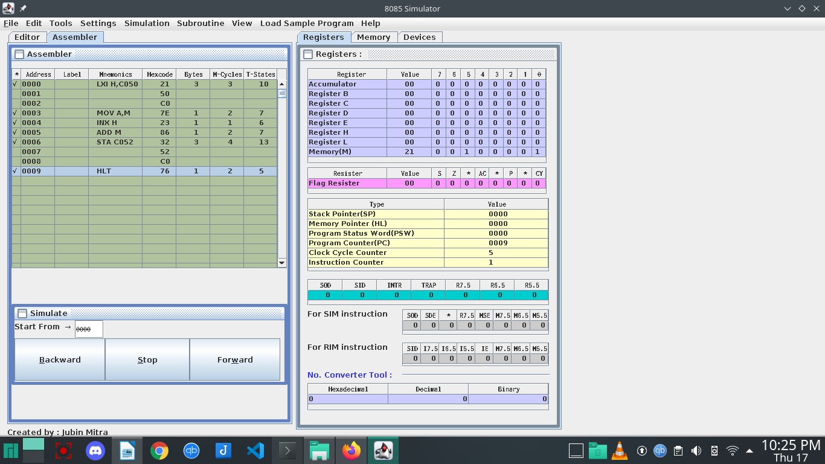
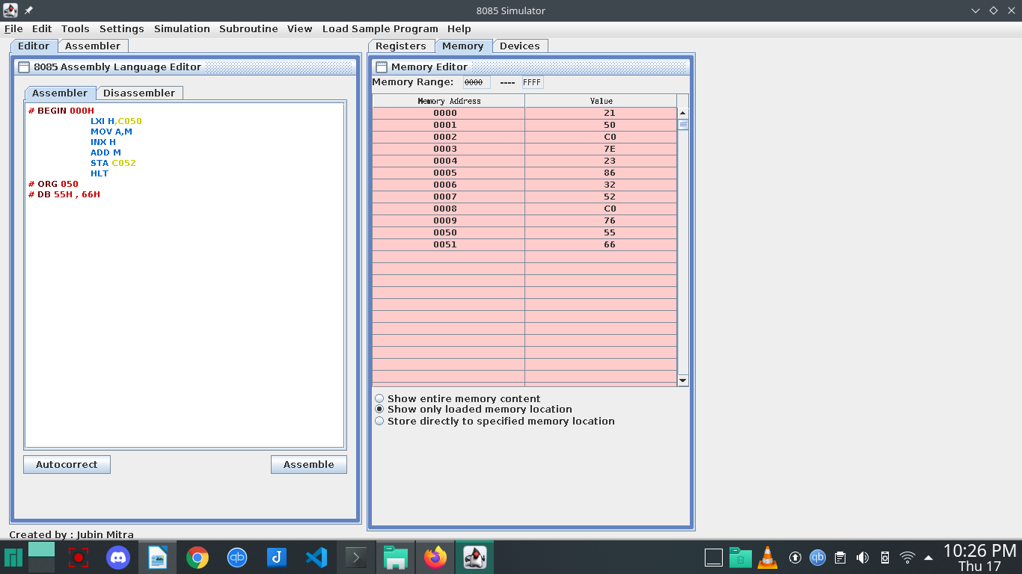
Question 1:

(b)

LHLD C052
XCHG
MVI C,00
DAD D

STA C056
SHLD C054
MOV A,C
STA C056
HLT
# ORG C050
# DB 45H, A6H , 23H, 9BH

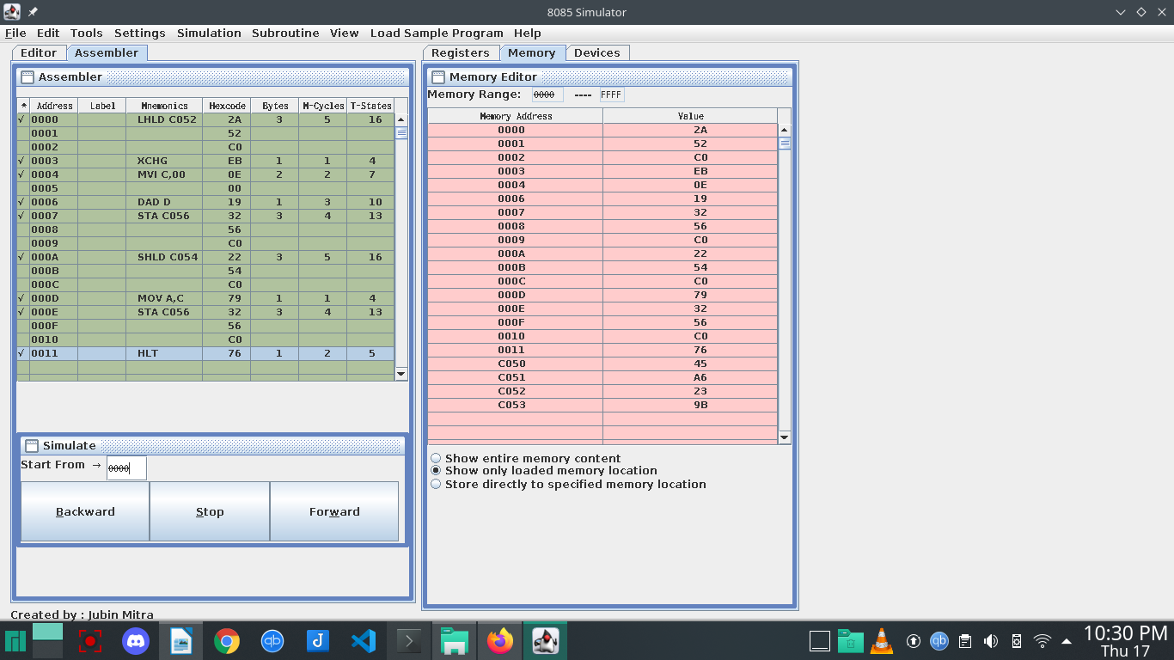
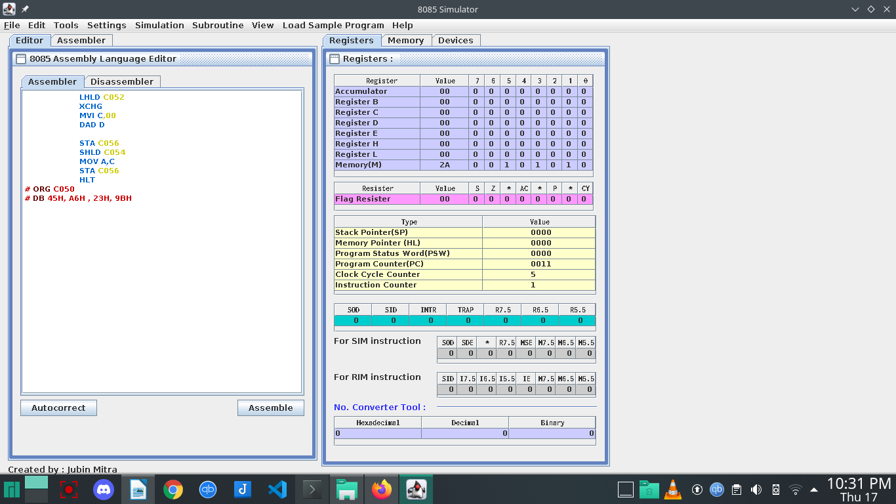
Question 1(c):

LXI H,C050
MOV A,M
INX H
SUB M
INX H
MOV M,A
HLT
# ORG C050
# DB 95H, 65H
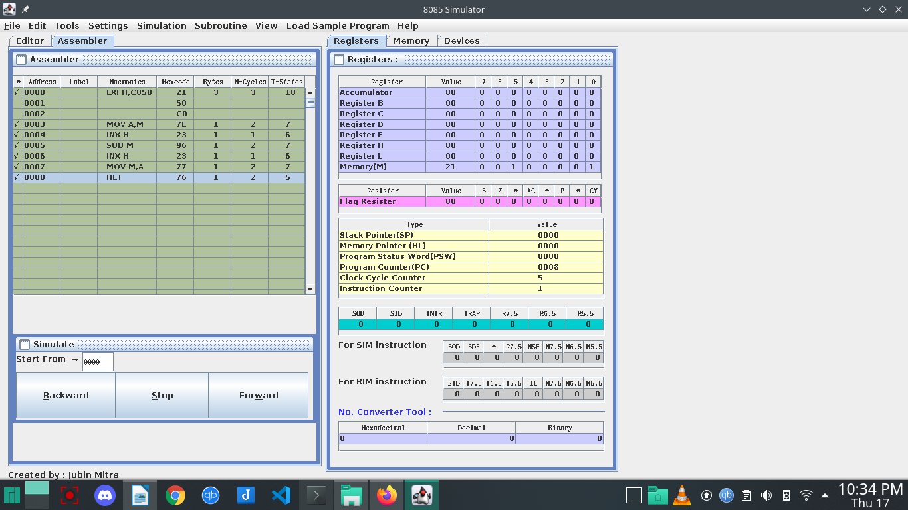
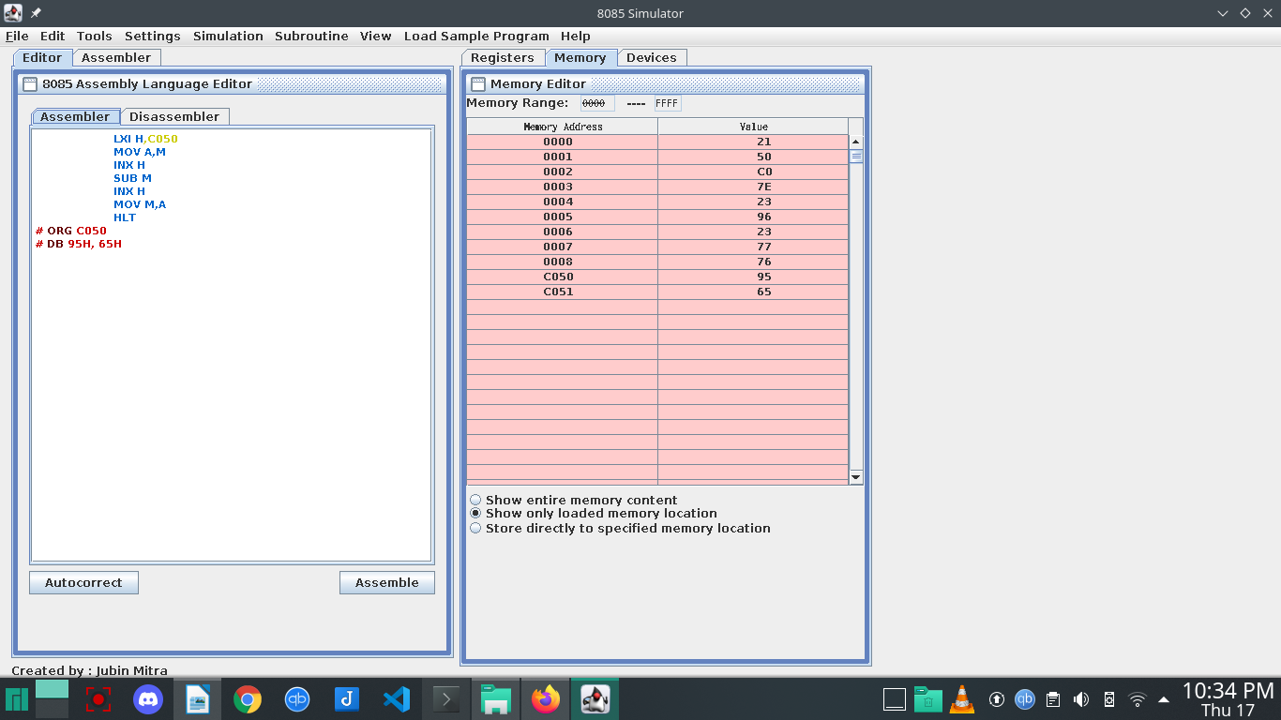
Question 1:

(d)
LHLD 4000
XCHG
LHLD 4002
MOV A,E
SUB L
MOV L,A
MOV A,D
SBB H
MOV H,A
SHLD 4004
HLT
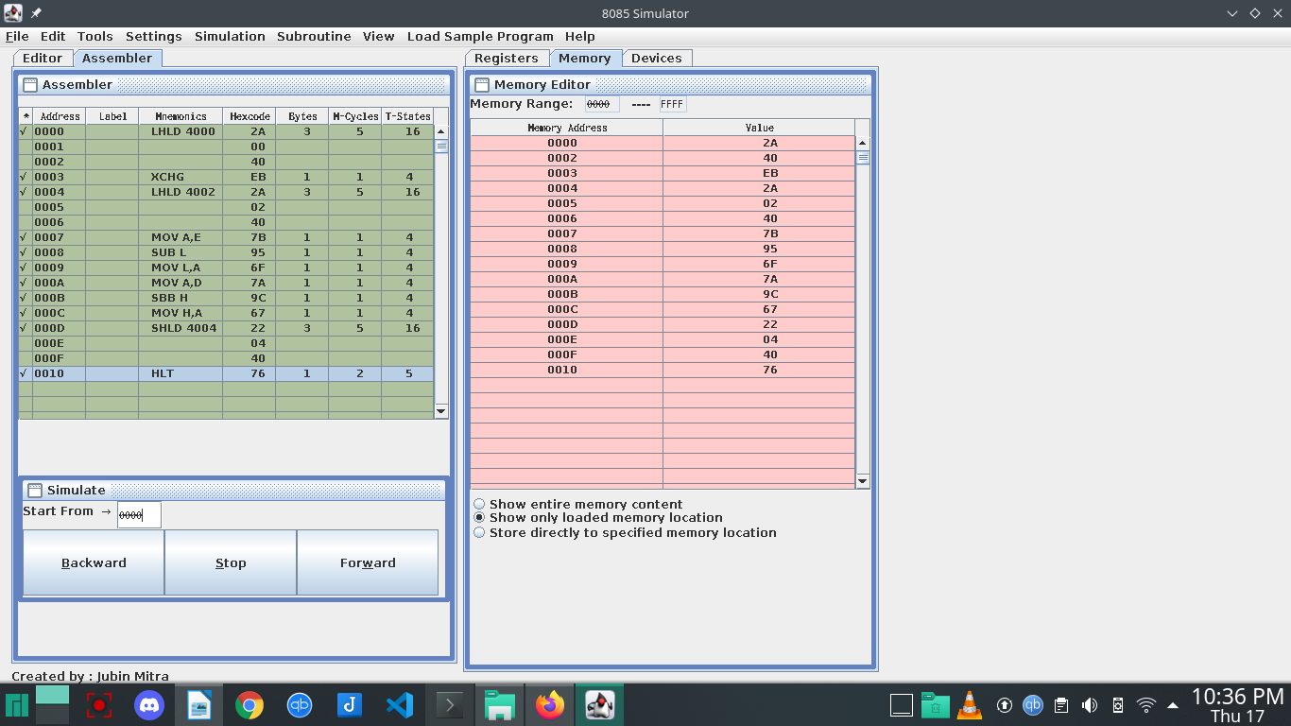
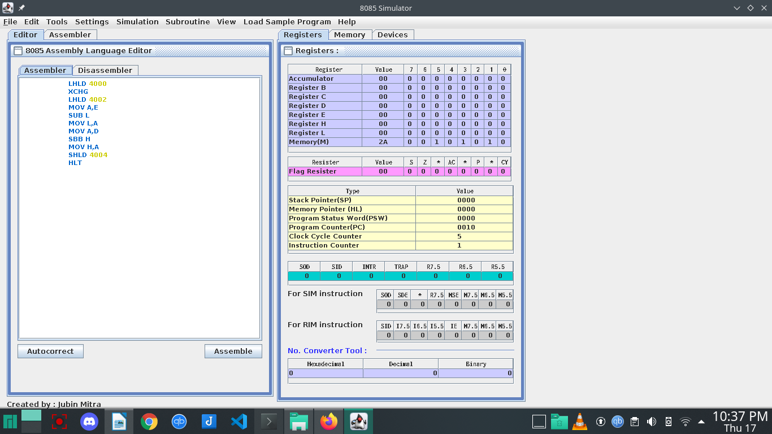
Question 2:

(a)

# ORG 2000H
# BEGIN 2000H
LHLD 0250

LDA 2503
LXI H,0000
MVI C,08

LOOP: DAD H
RAL
JNC AHEAD
DAD D

AHEAD: DCR C
JNZ LOOP
SHLD 2504
HLT
# ORG 2501H
# DB 84H,00H,56H
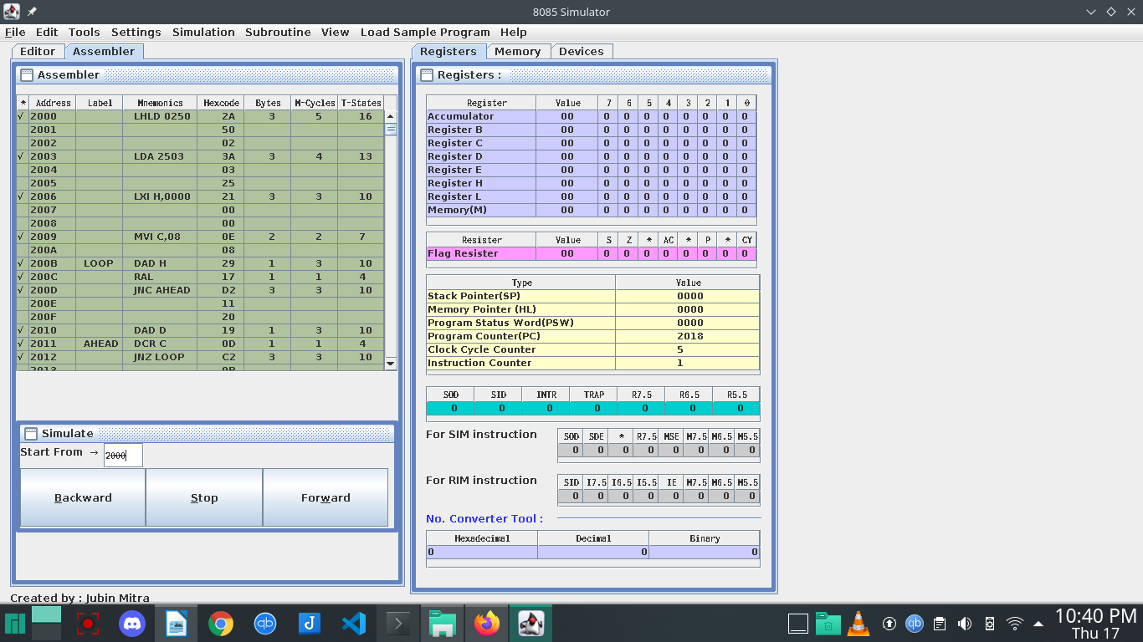
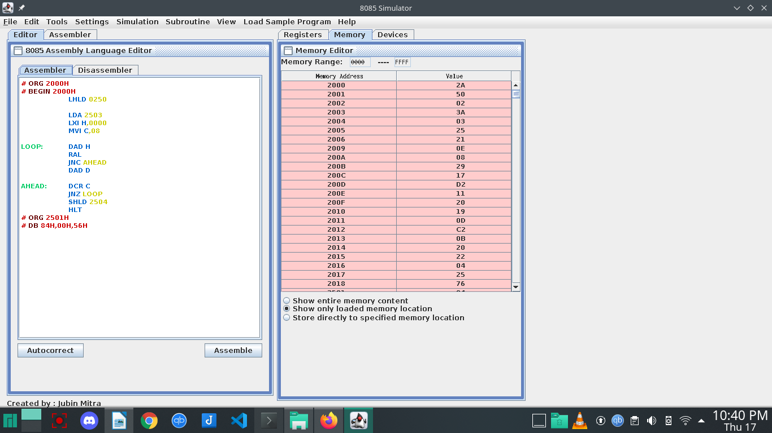
Question 2:

(b)

# ORG 2000H
# BEGIN 2000H
LHLD 2501
LDA 2503
MOV B,A
MVI C,08

LOOP: DAD H
MOV A,H
SUB B
JC AHEAD
MOV H,A

AHEAD: DCR C

SHLD 2504
HLT
# ORG 2501H
# DB 9BH, 48H, 1AH

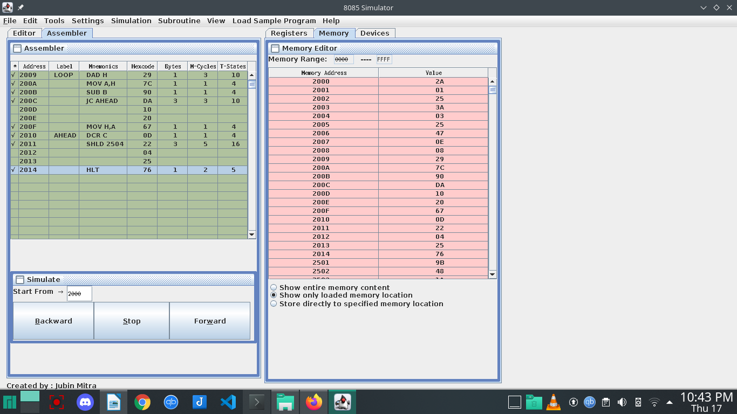
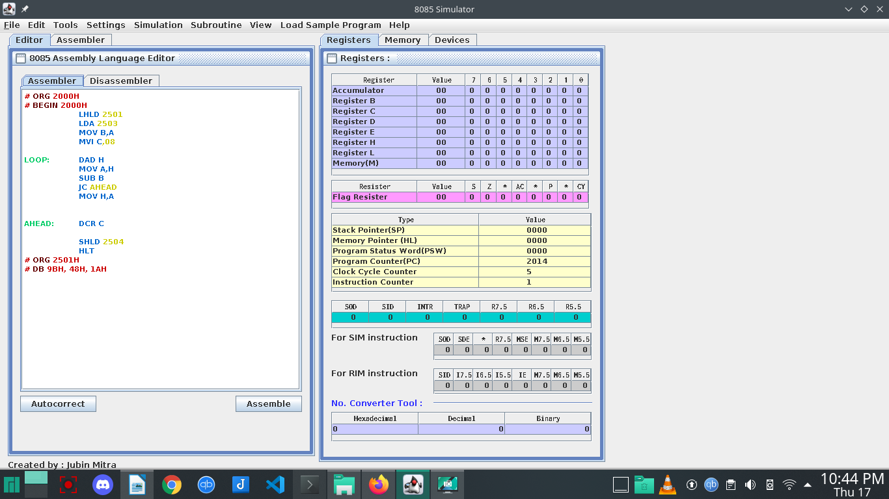
Question 3:

(a)

LXI H,5000
MOV B,M
INX H
MOV A,M
DCR B

LOOP: INX H
CMP M
JNC AHEAD
MOV A,M

AHEAD: DCR B
JNZ LOOP
STA 6000
# ORG 5000
# DB 05H, 08H, 03H, 05H, 02H, 07H
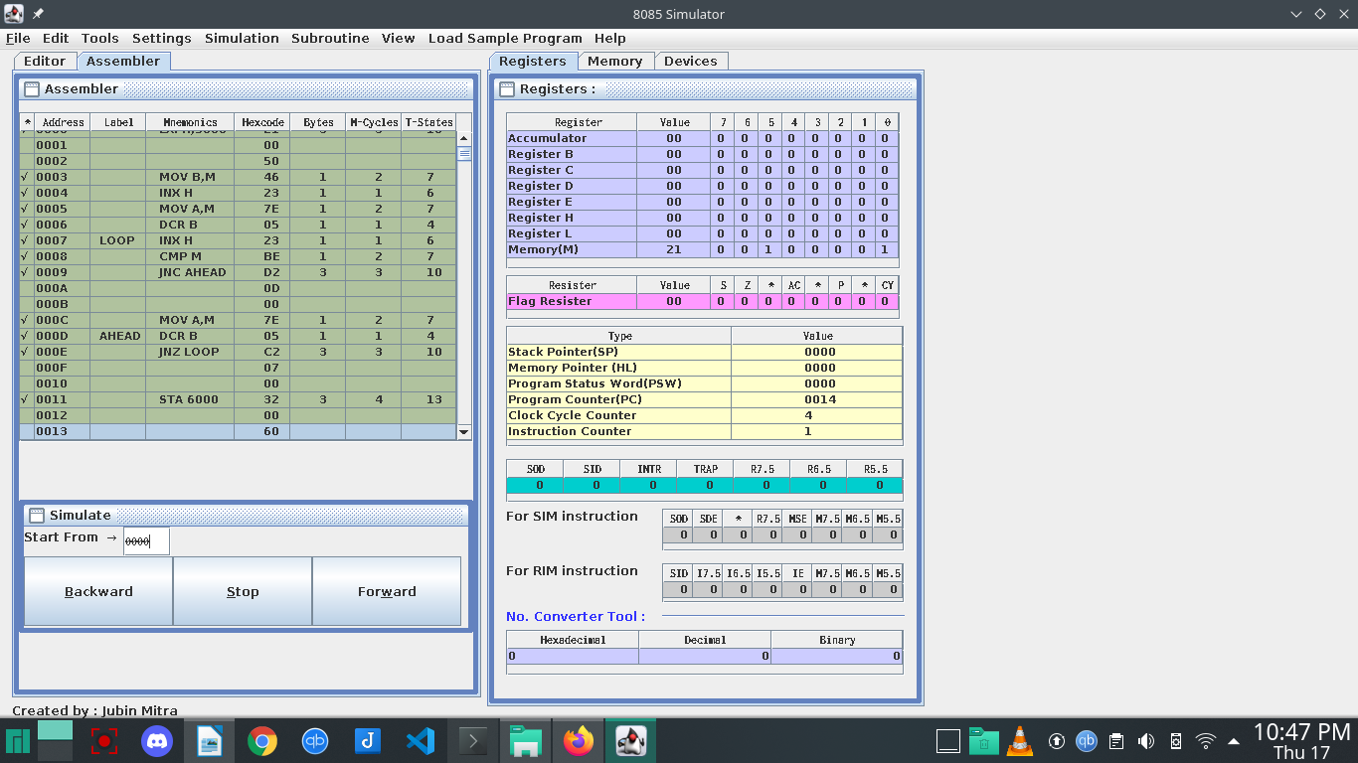

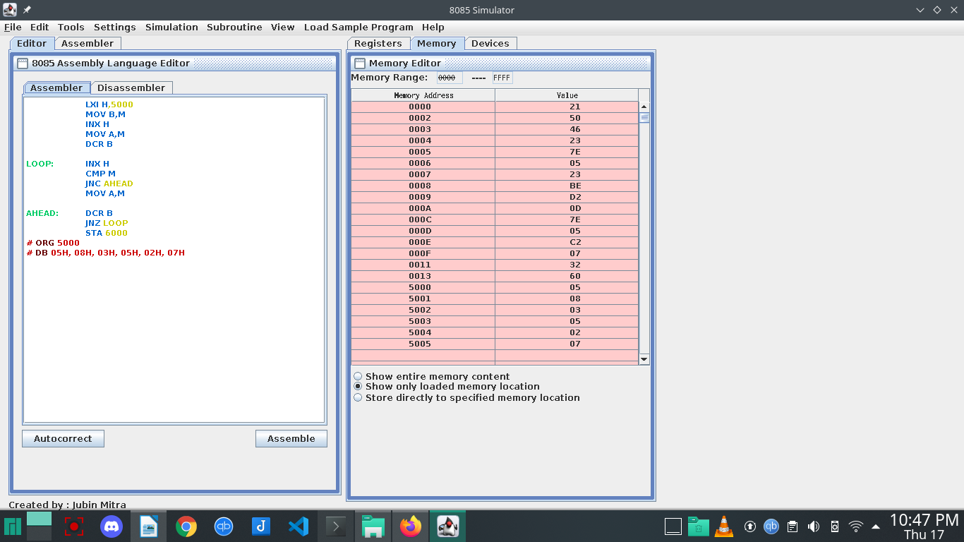
Question 3:

(b)

LXI H,5000
MOV B,M
INX H
MOV A,M
DCR B

LOOP: INX H
CMP M
JC AHEAD
MOV A,M

AHEAD: DCR B
JNZ LOOP
STA 6000
# ORG 5000
# DB 05H, 0AH, F1H, 1FH, 26H, FEH

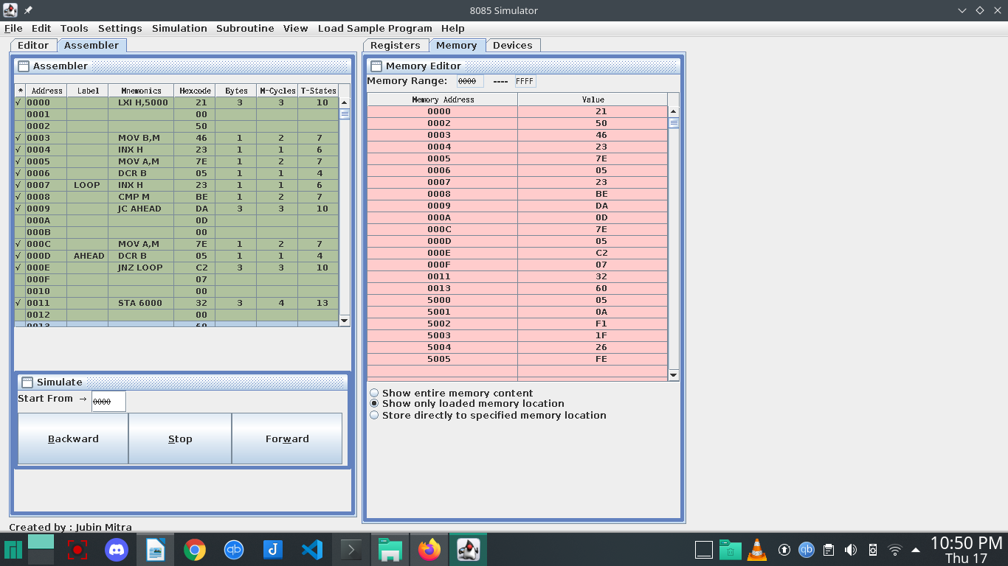
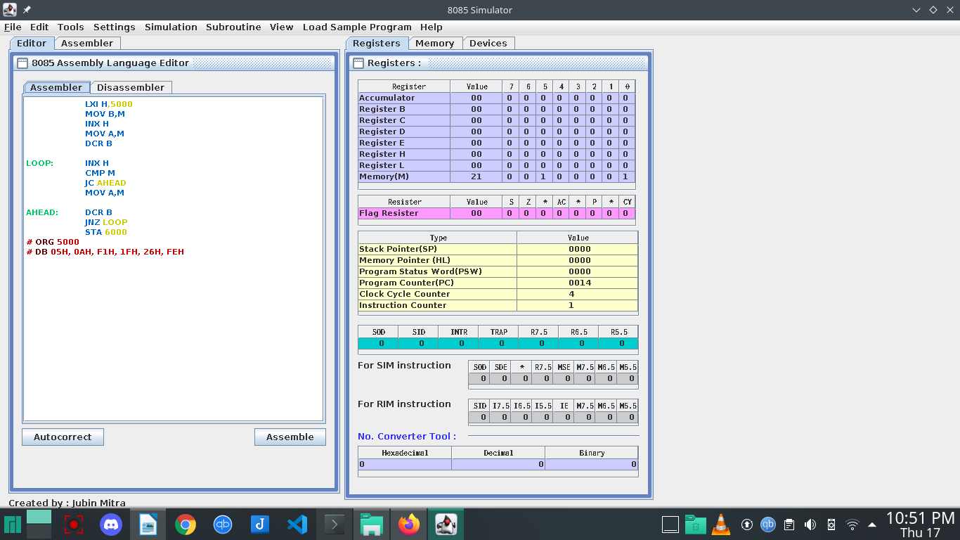
Question 4:

MVI A,06

MOV E,A

LOOP1: DCR E
JZ END
MOV D,E
MVI H,00
MVI L,00

LOOP2: DAD B
DCR D
JNZ LOOP2
MOV B,H
MOV C,L
JMP LOOP1

END: HLT
HLT

